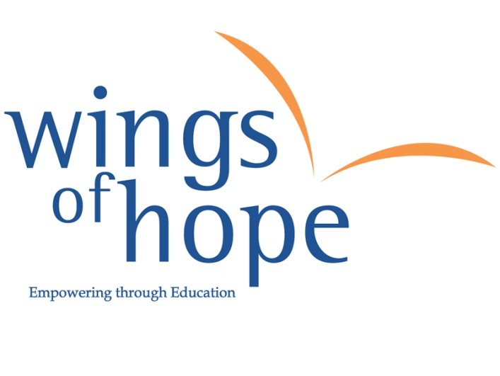
Friday 11th November

Get Your “Wings” On!

…How will you wear yours?
Wear wings for £1 and check out themed events across your school

All in support of educating underprivileged kids in Africa and India giving them “wings of hope”
T: 0208 438 1598

www.thewingsfhope.org

WOHAA!
Brought to you by

UK Registered charity number: 1099685

